**PRACTICAL: 5**

**IMPLEMENT ESXi SERVER**

Open VMware Workstation – And select Create a New Virtual Machine >> Select Typical and click Next.

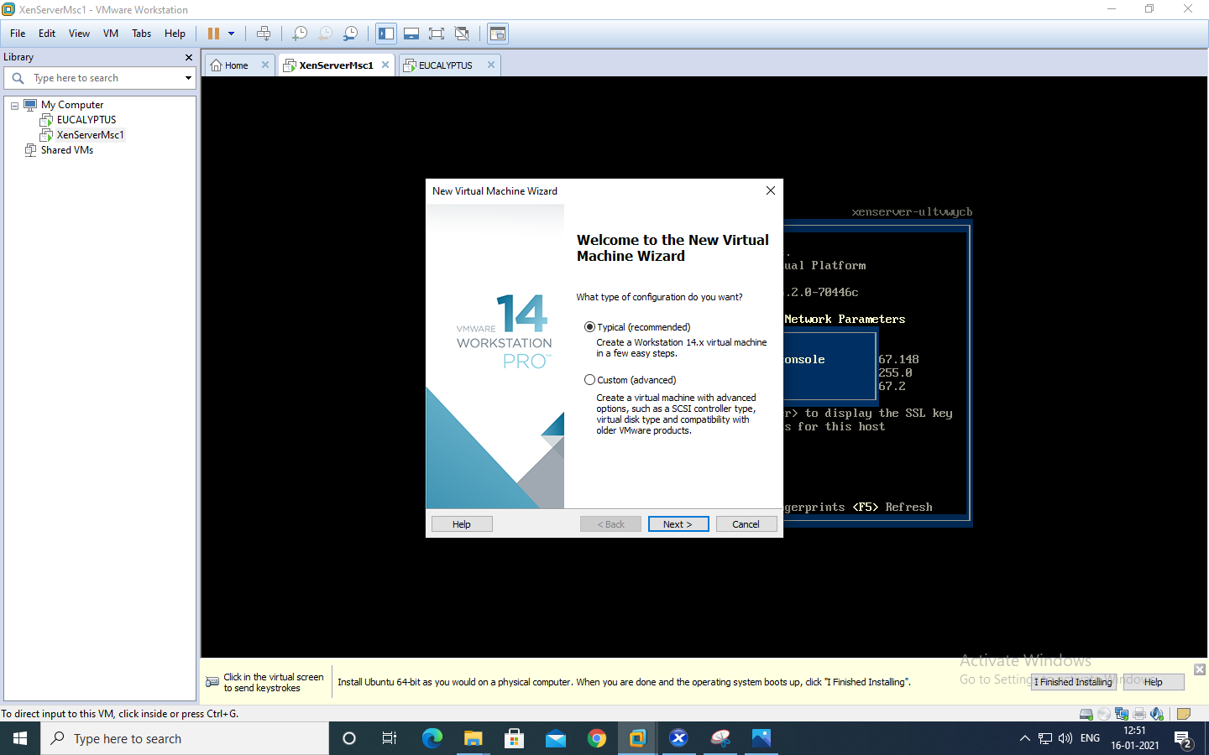

Select Installer disc_image file(ISO). Click Browse -ESXi-5.x-Custom.iso Iso File – For Example “D:\ccpraxrj\ESXi-5.x-Custom.iso” >> And click on next

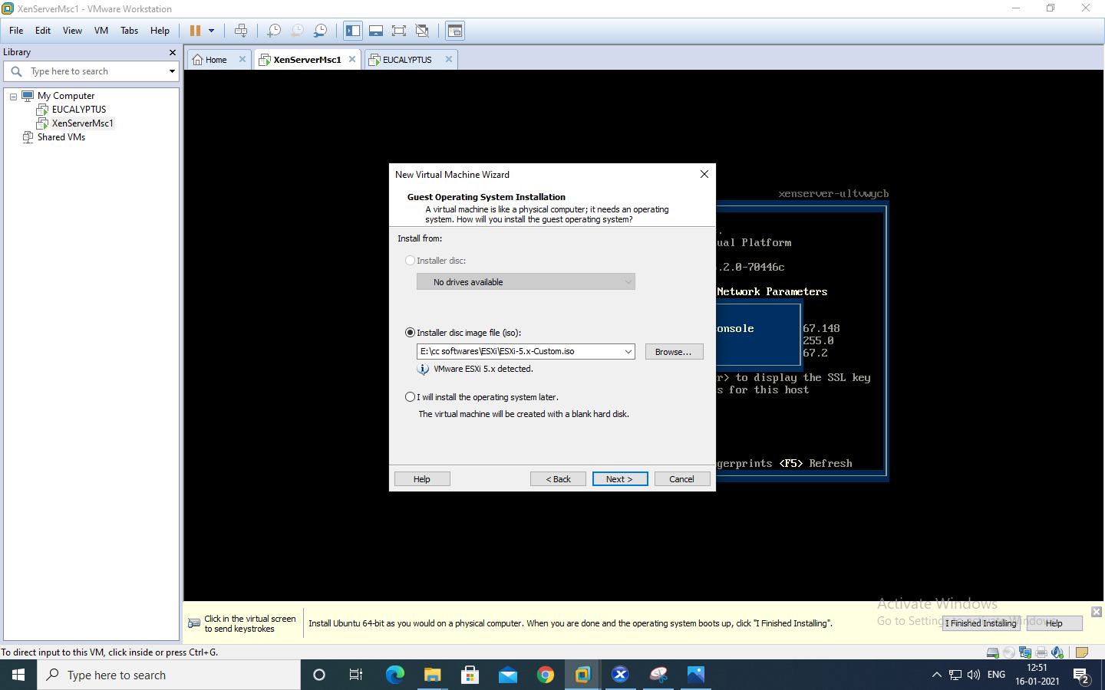

Change maximum disk size to 60 GB and check –Store virtual disk as single file

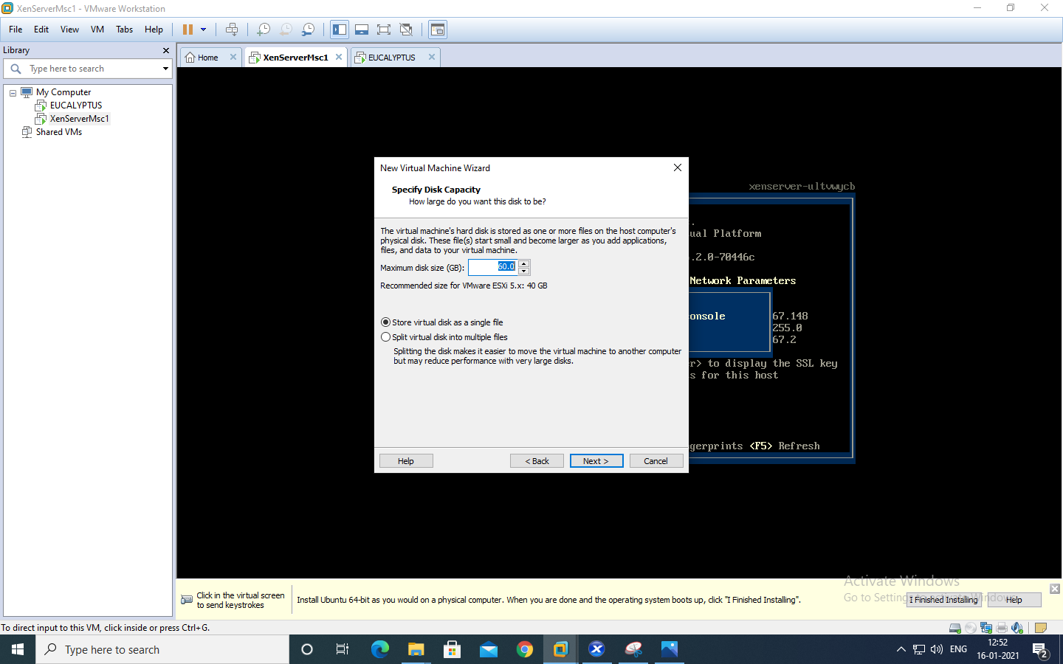

Click on Customize Hardware option

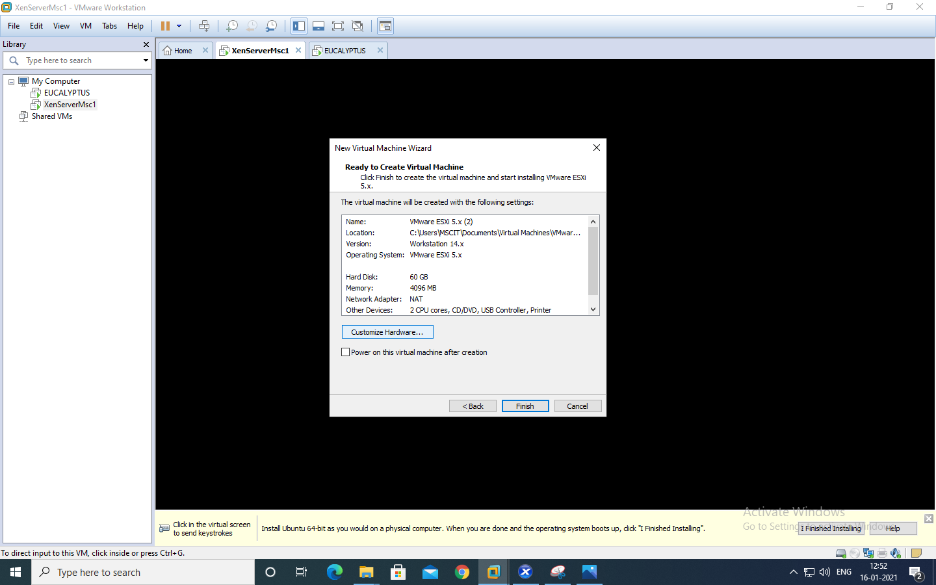

Change – Memory for this virtual machine to 4 GB and Click on Close.

Click on Processor and select virtualize Intel VT

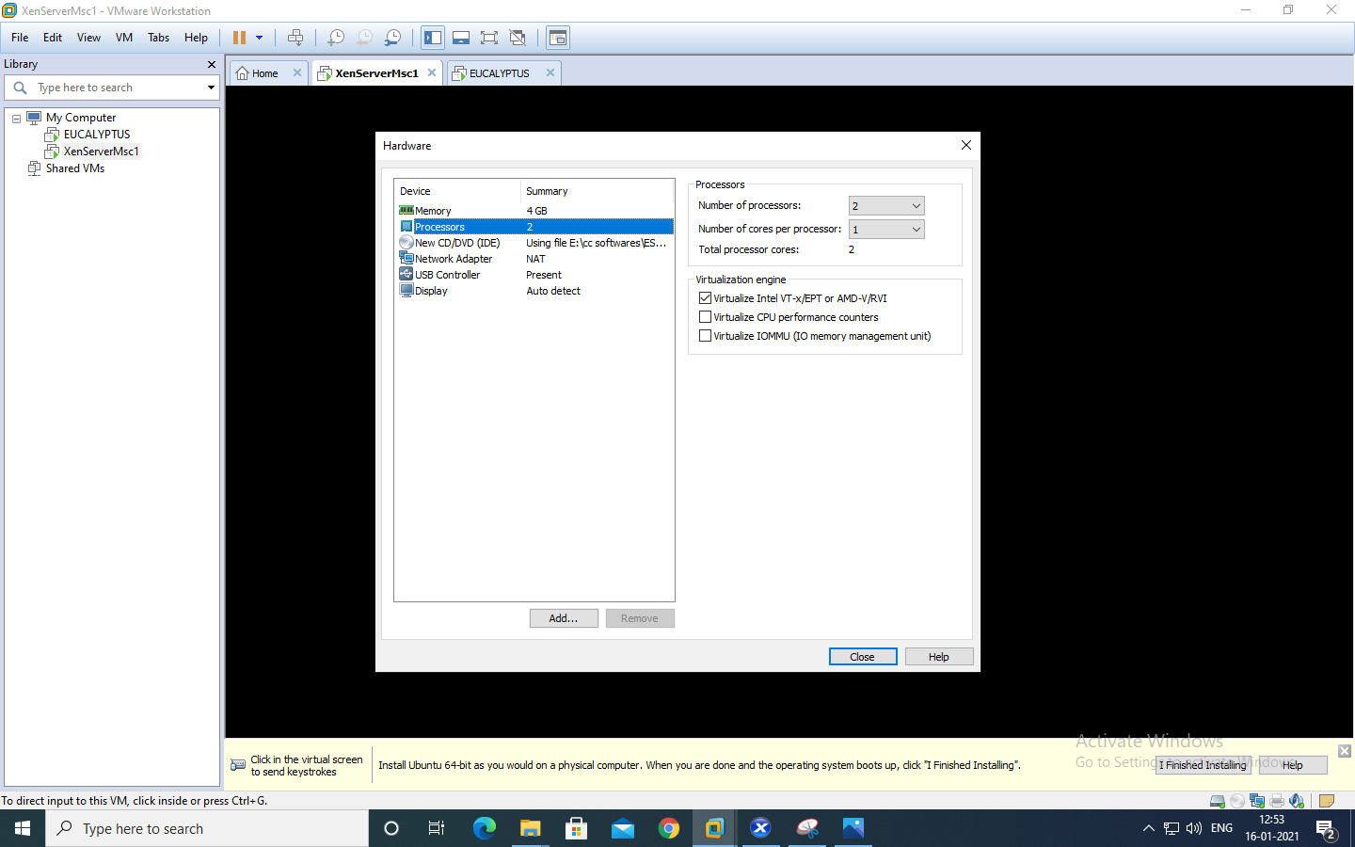

Now Power on newly created Virtual machine – >> Click on install EXSi server

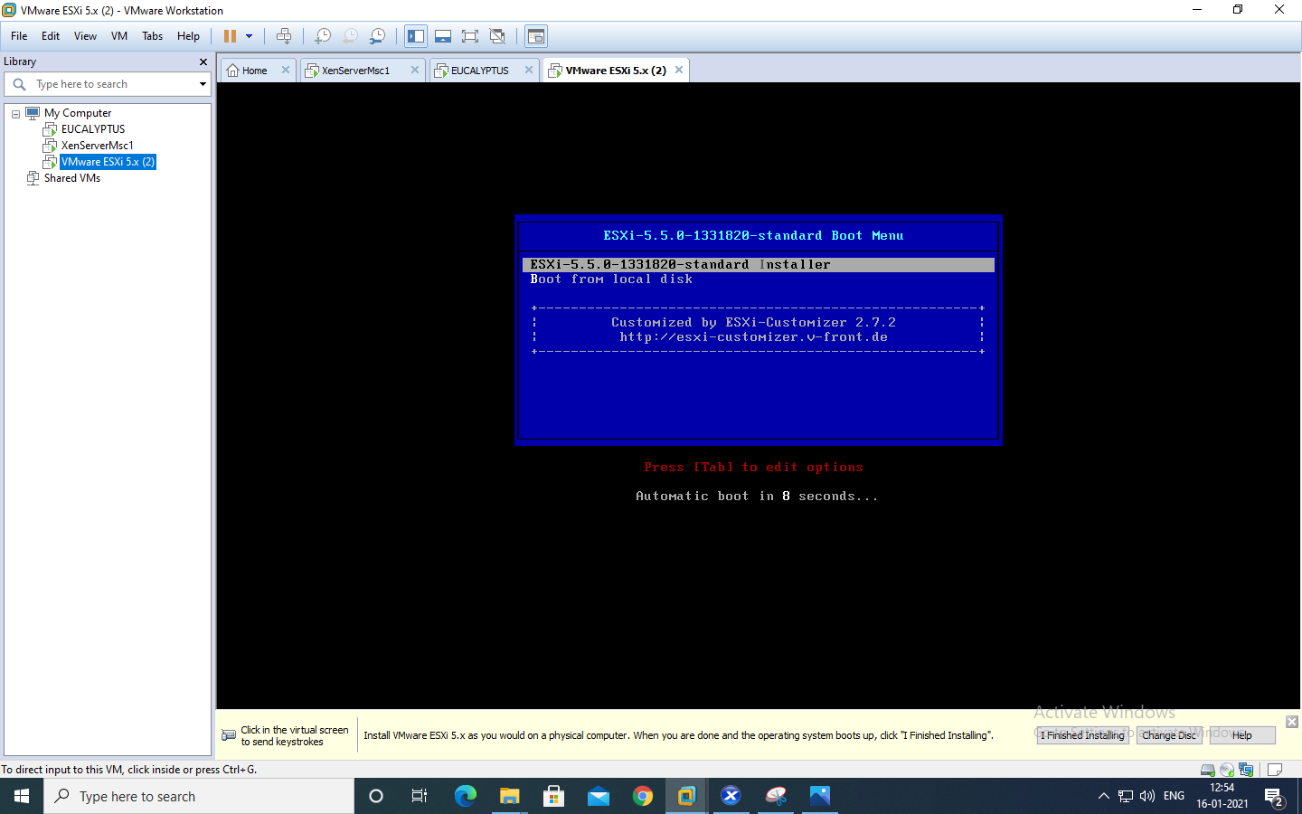

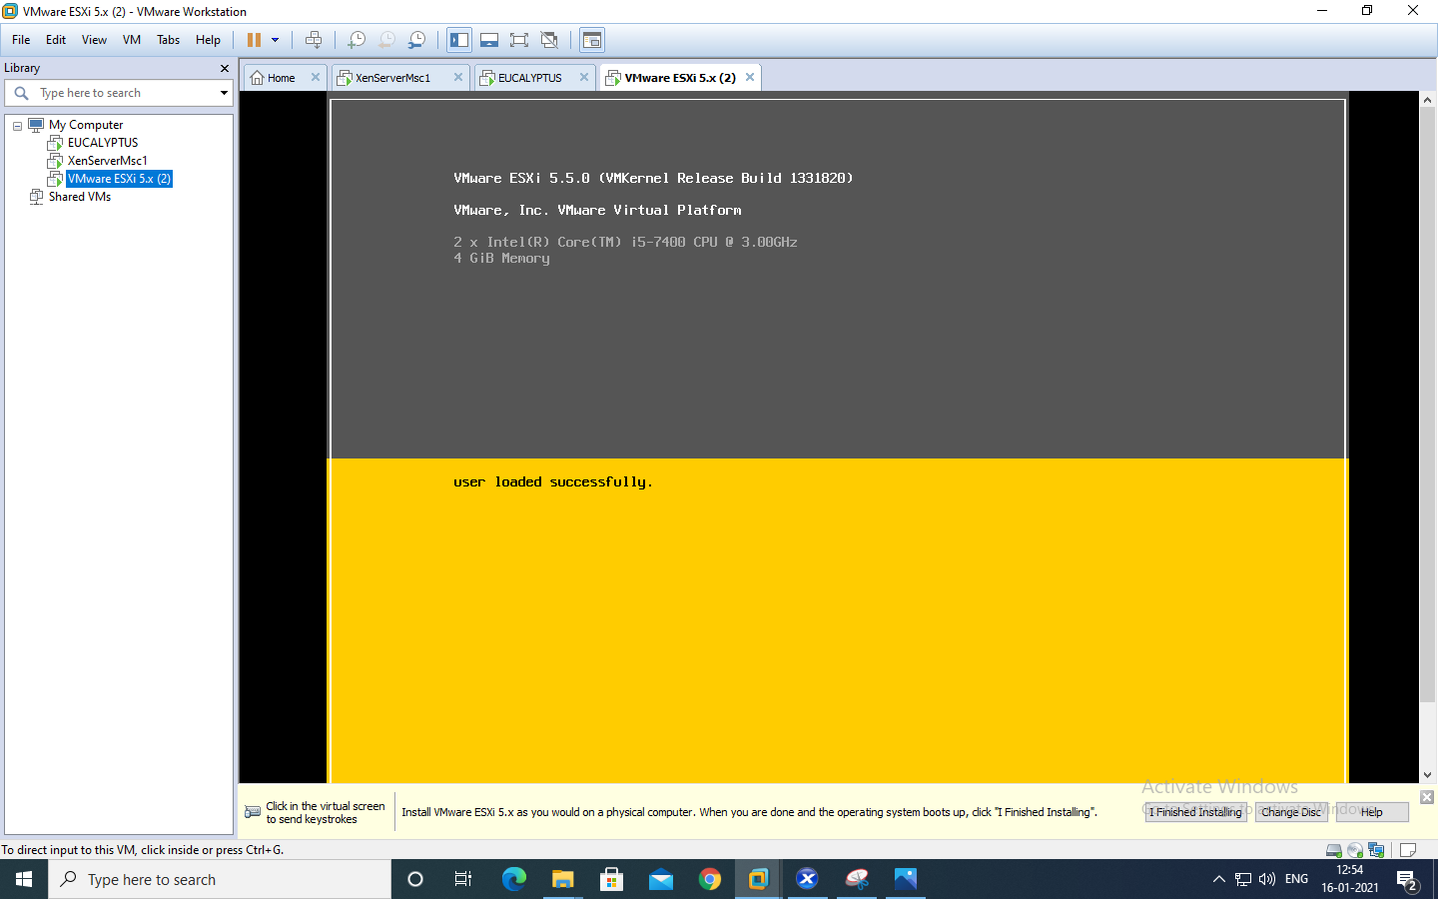

Press enter

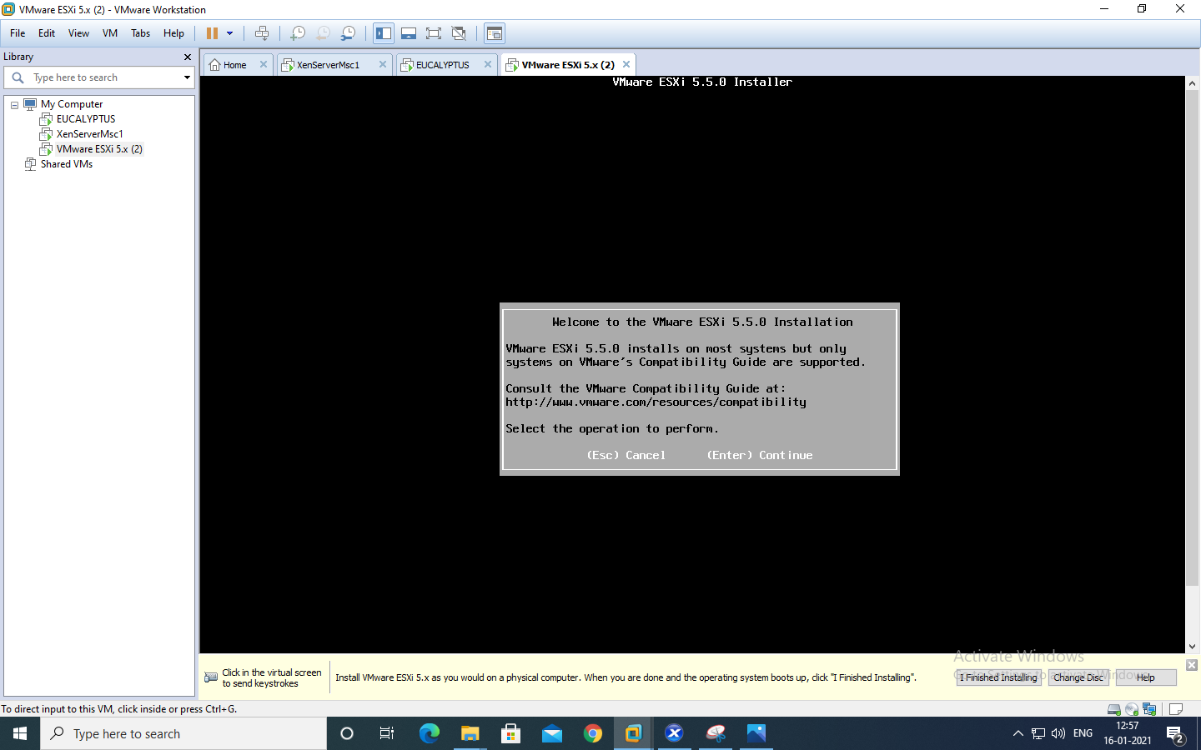

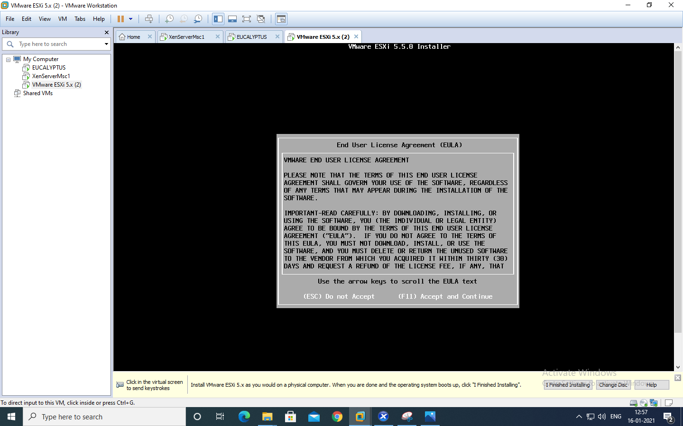

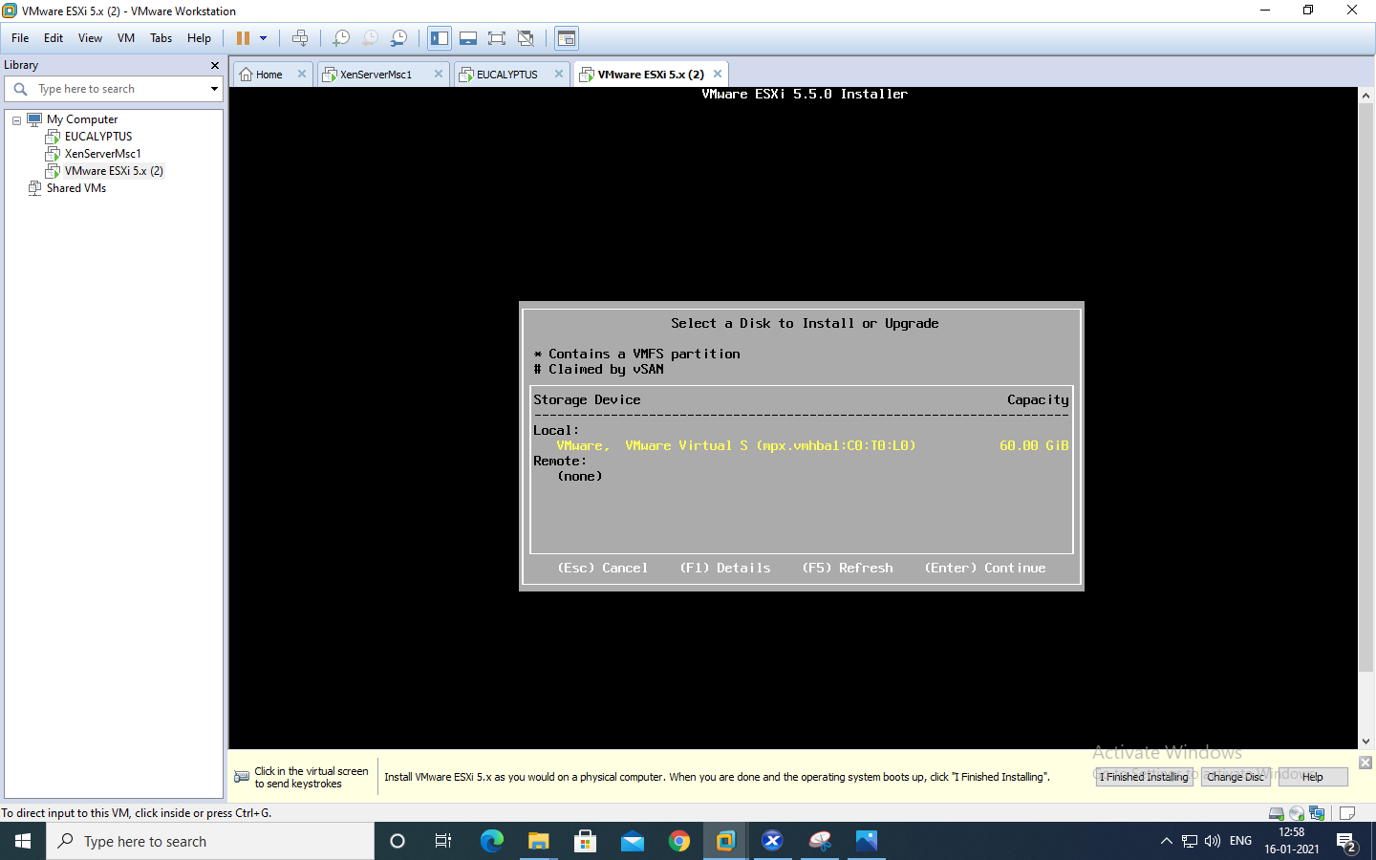

Select us default and click enter

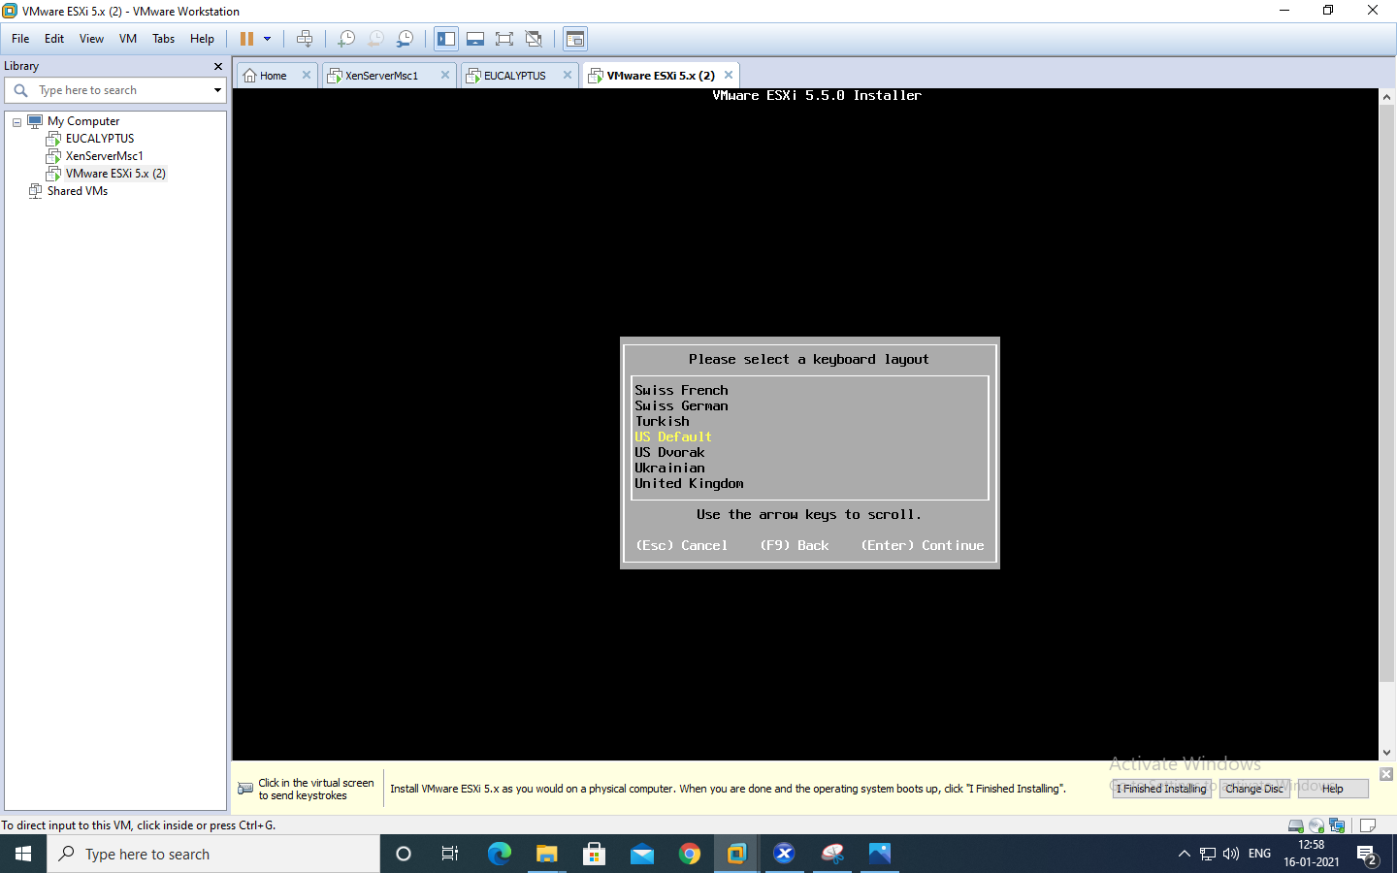

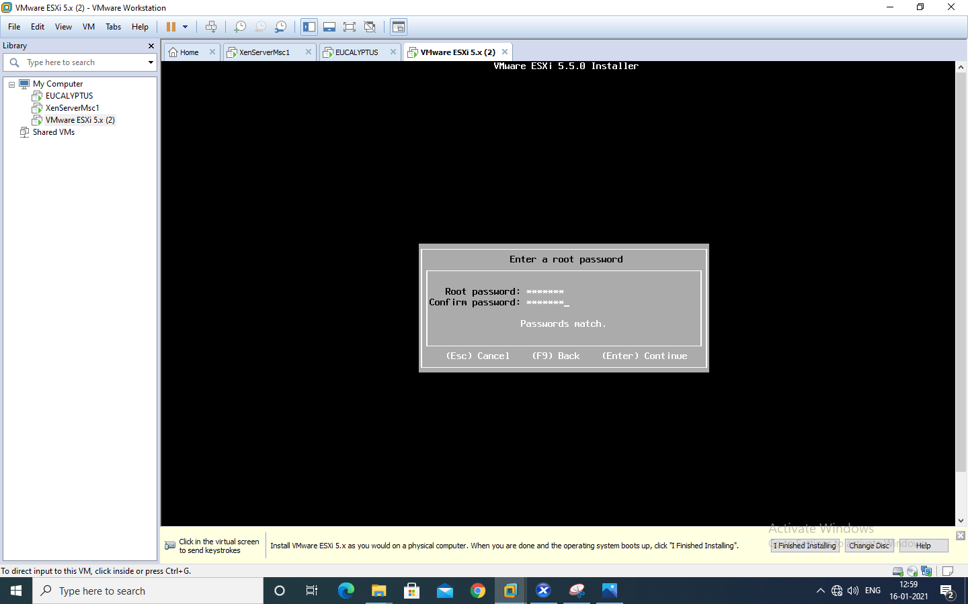

Click install

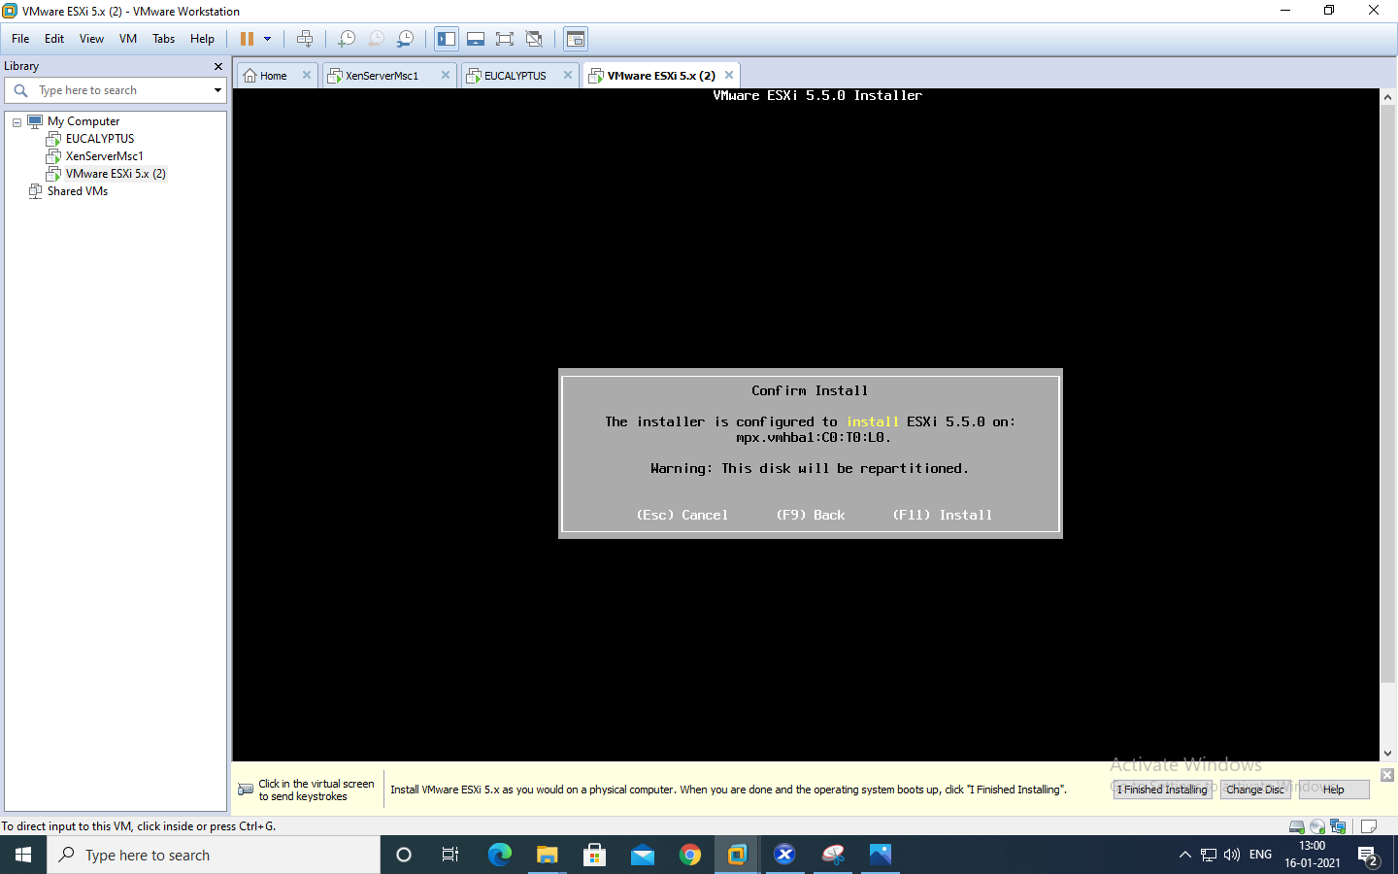

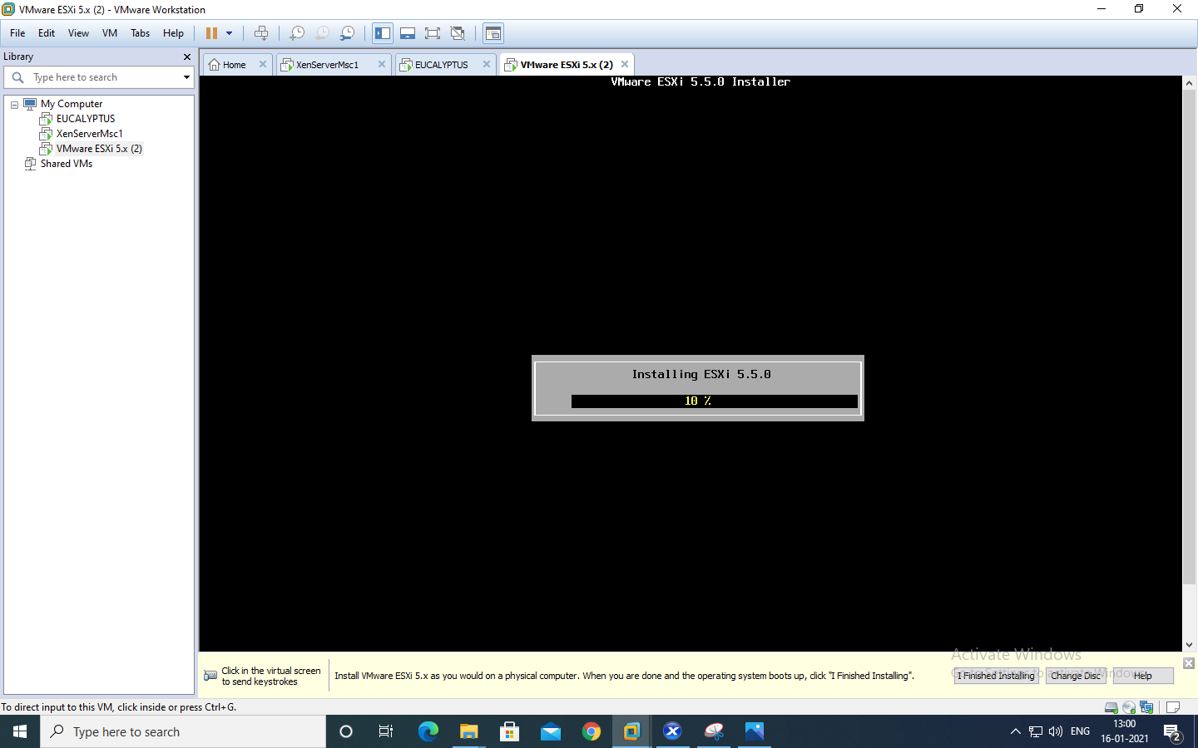

Press enter to reboot the system

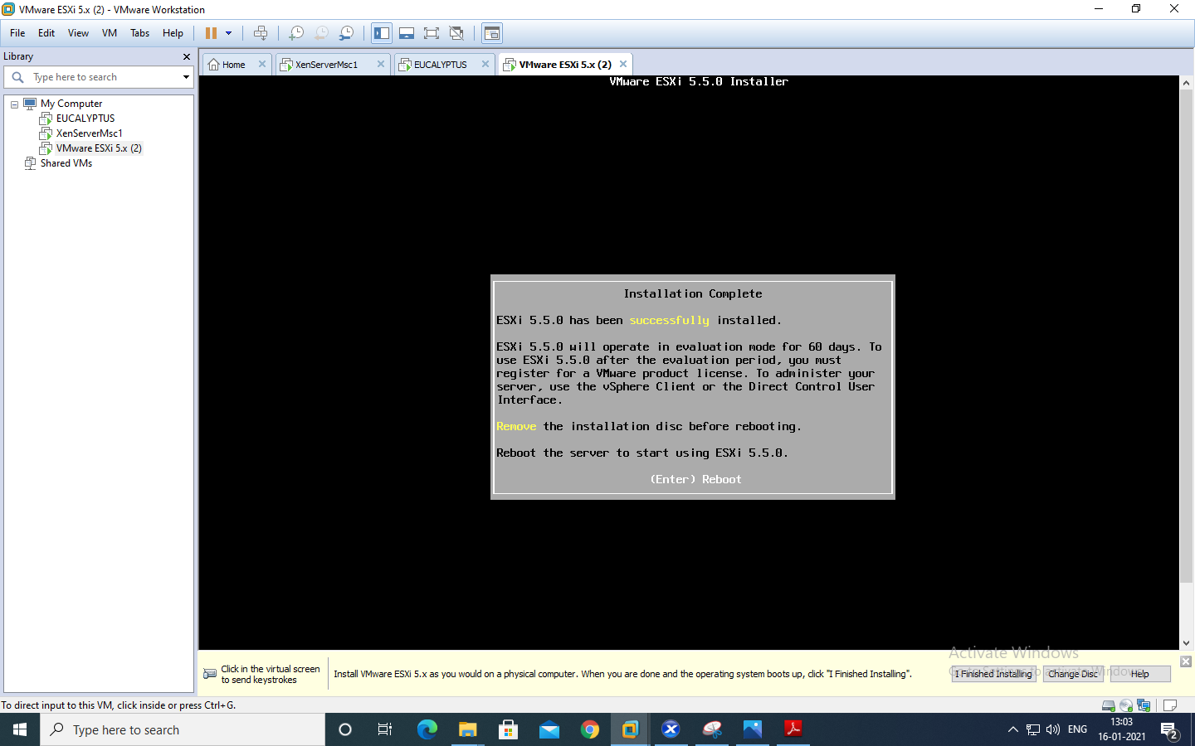

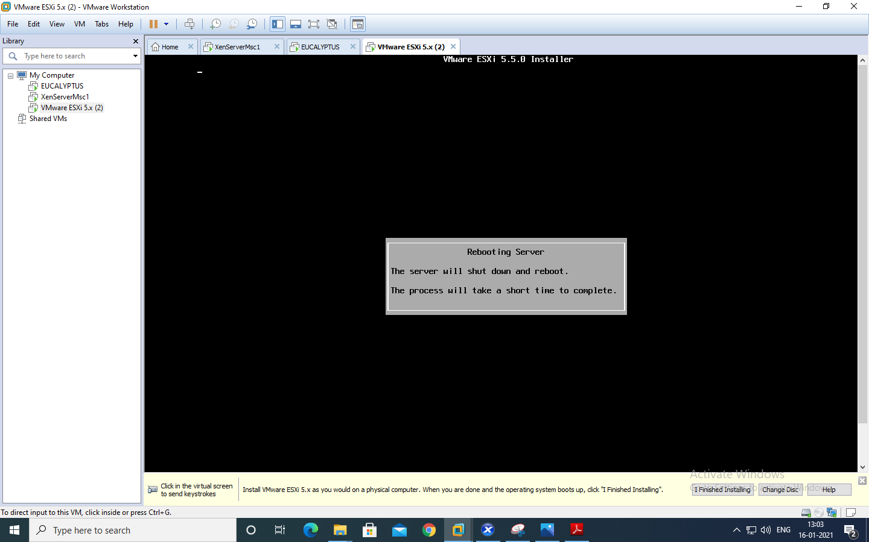

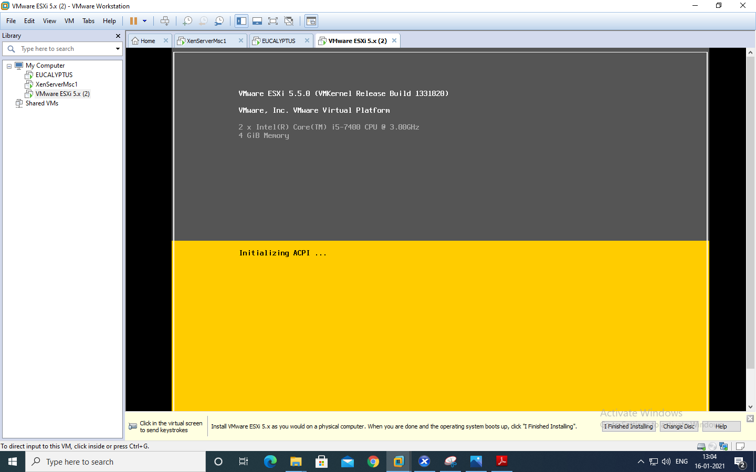

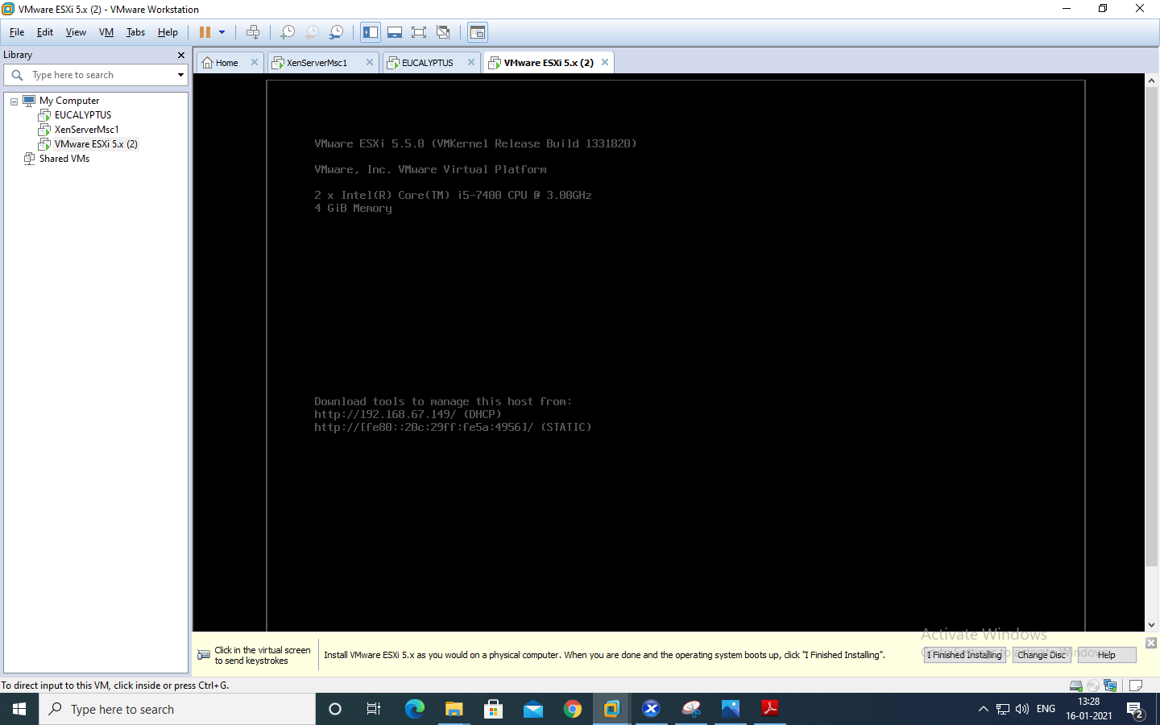

Open Browser & type respective IP Address

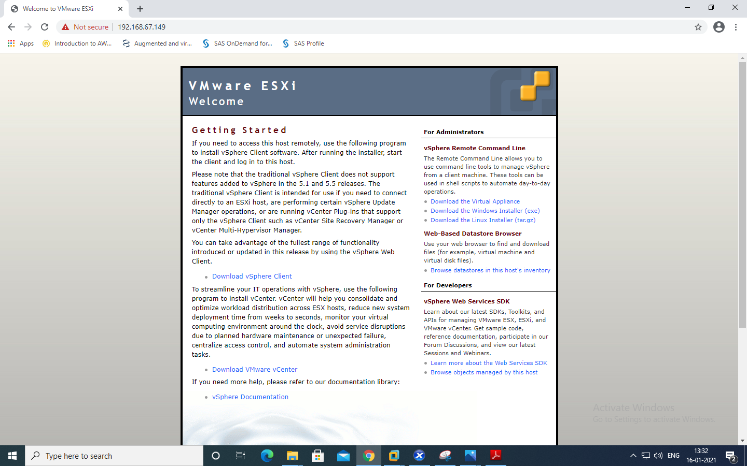

(since we already have vsphareclient so we are not going to download it,first install and open vsphareclient)

VMware vSphere Client

▪ Enter IP address (Which was assigned dynamically)

▪ Enter Username and Password

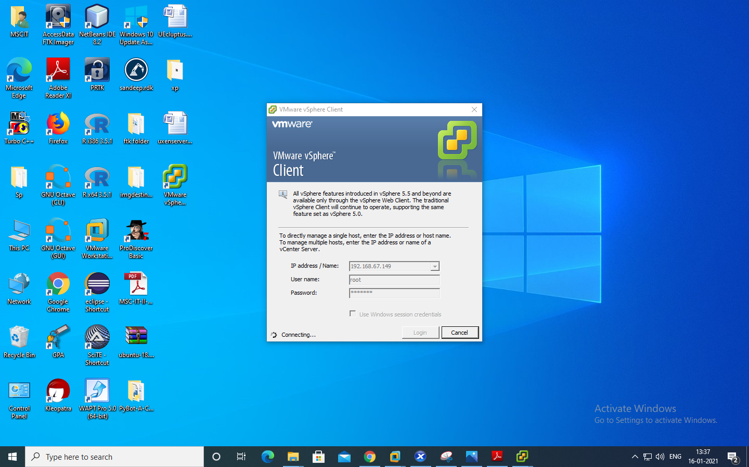

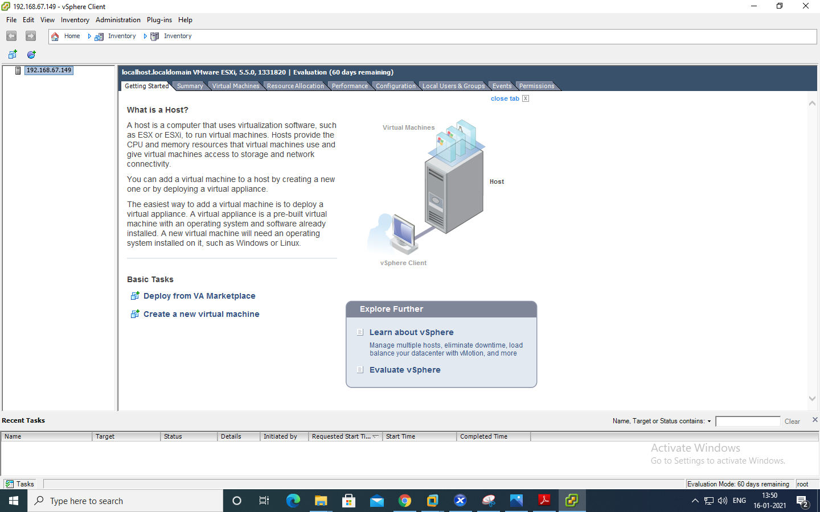

Select Summary tab.

▪ In Storage section, Select on datastore1 and Right-click on Browse Datastore to add iso image of Windows XP in Datastore.

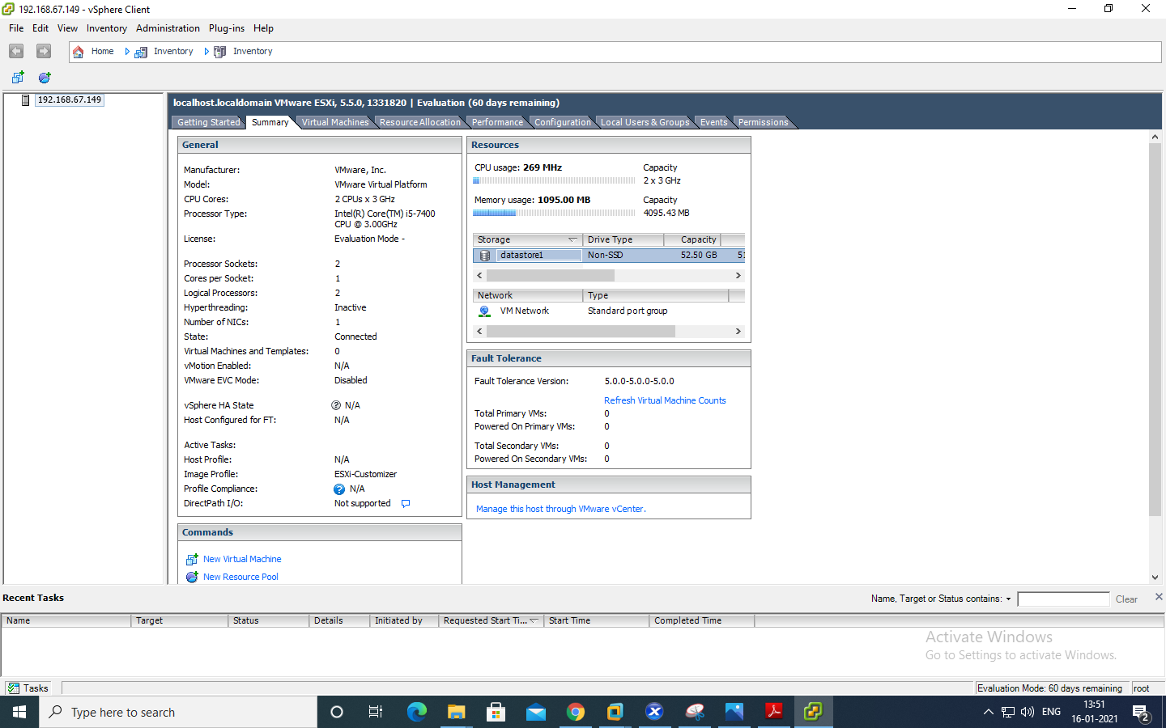

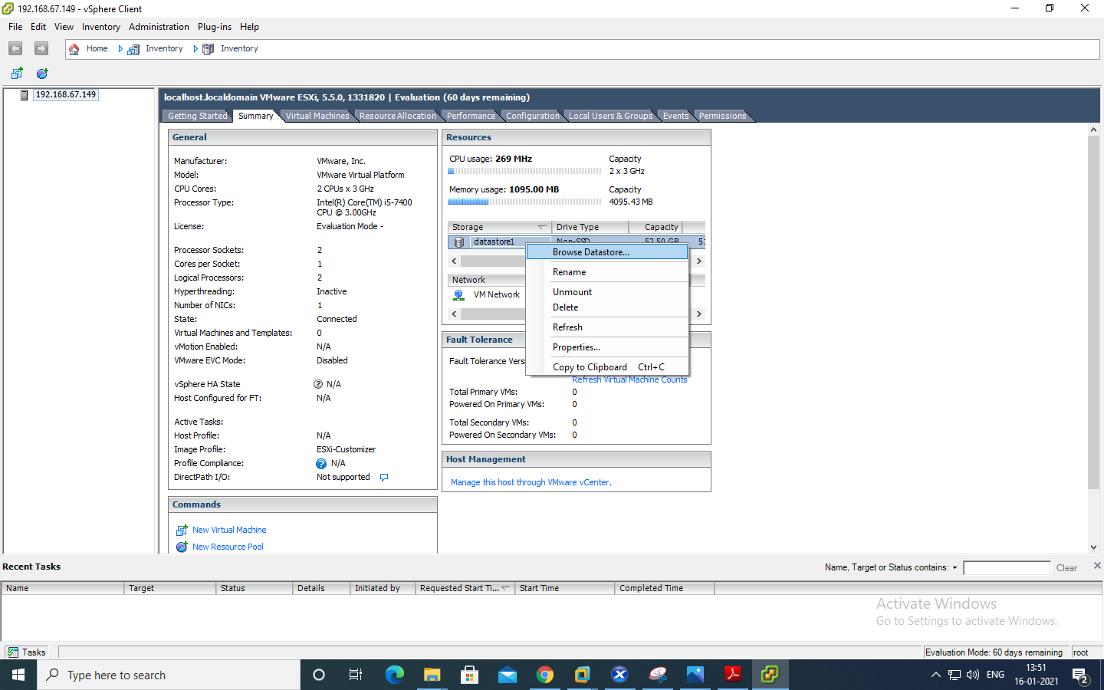

Click on Upload Icon and Select Upload File >> Click on Yes

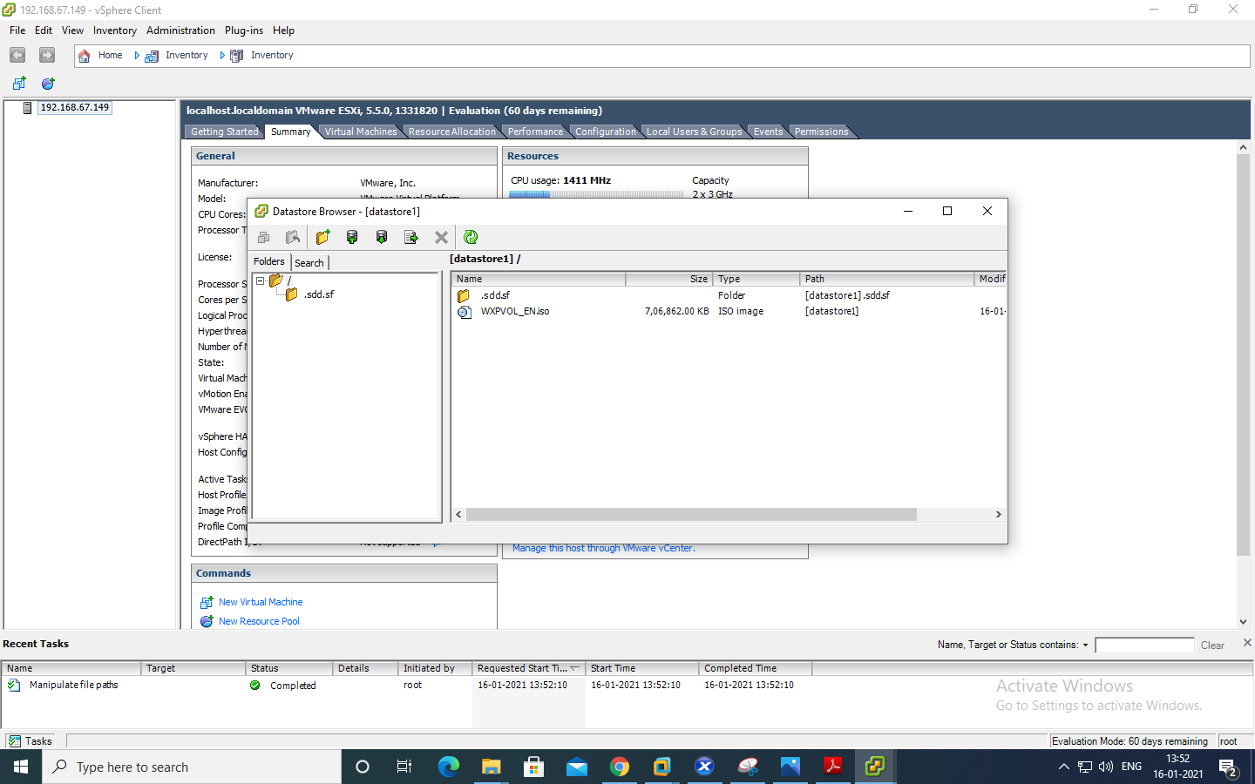

Click on File >> New >> Virtual Machine.

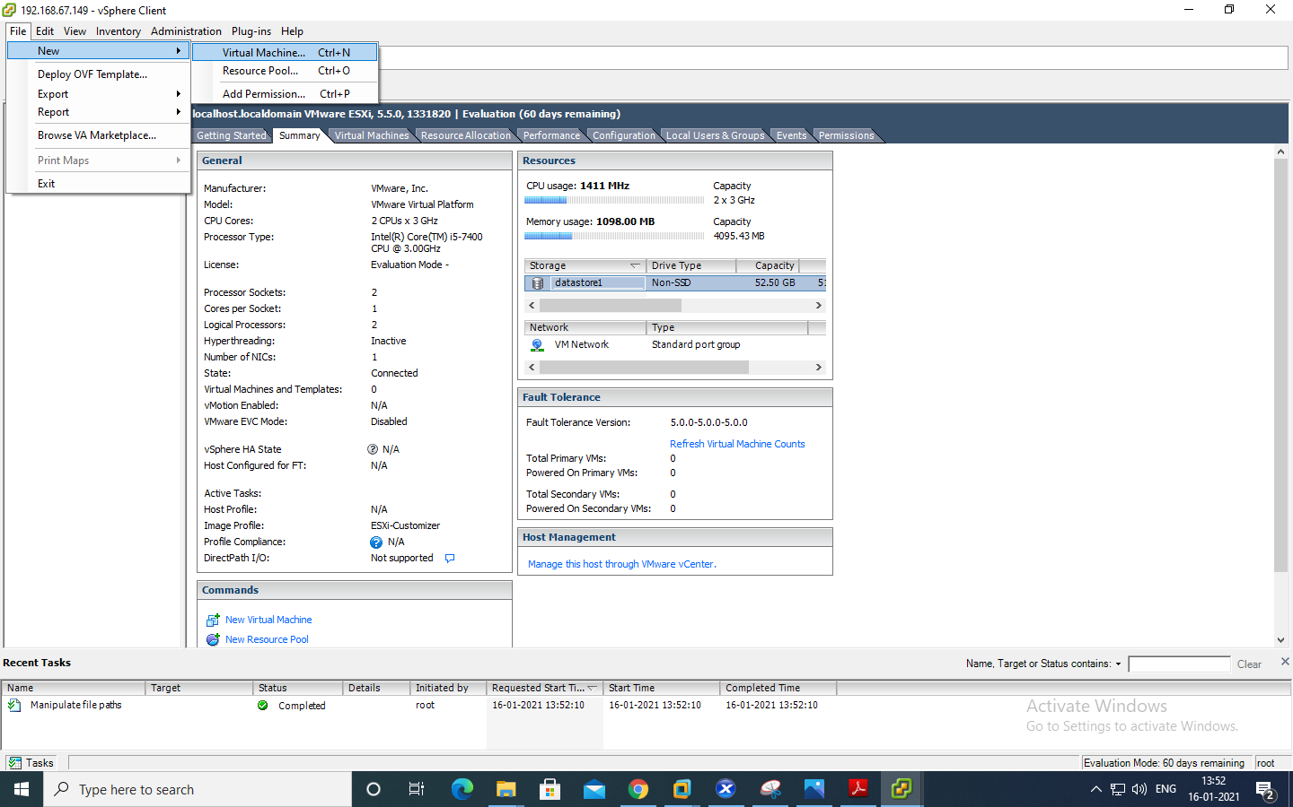

Configuration : Select Custom configuration.

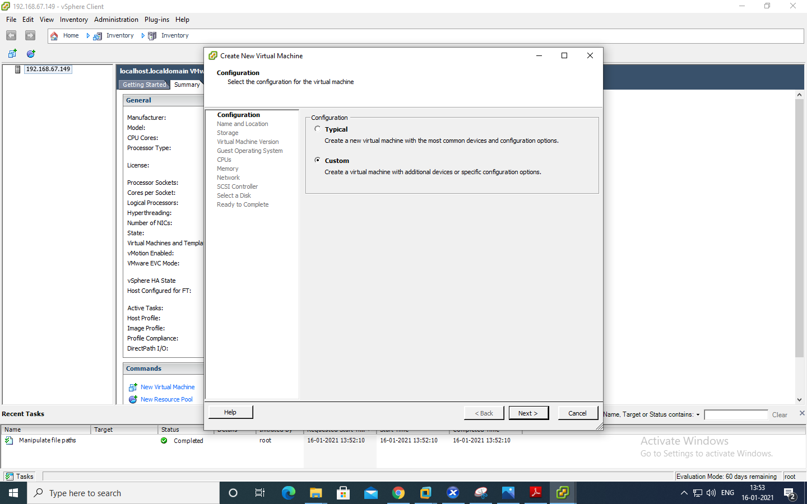

Name and Location: Give name to a Virtual Machine(Windows XP)

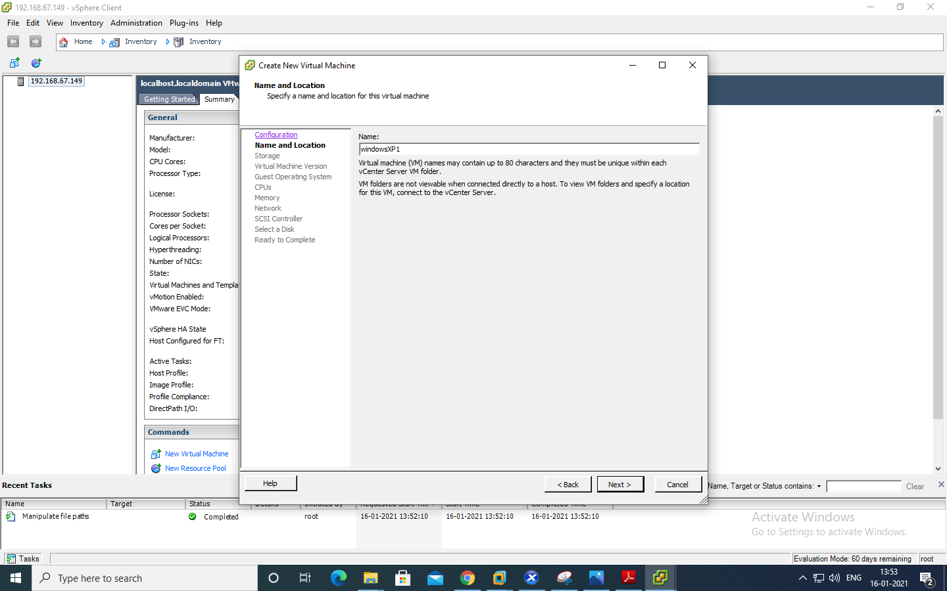

Storage:Select datastore1 and click Next

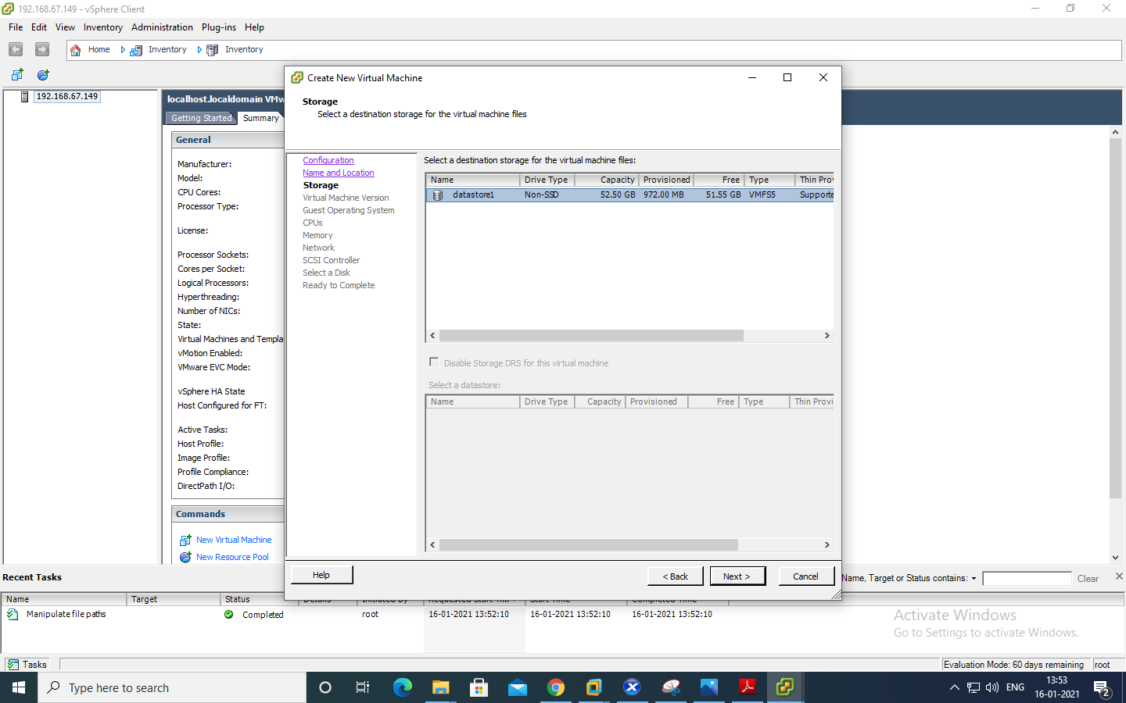

Virtual Machine version : Select Virtual Machine version 8

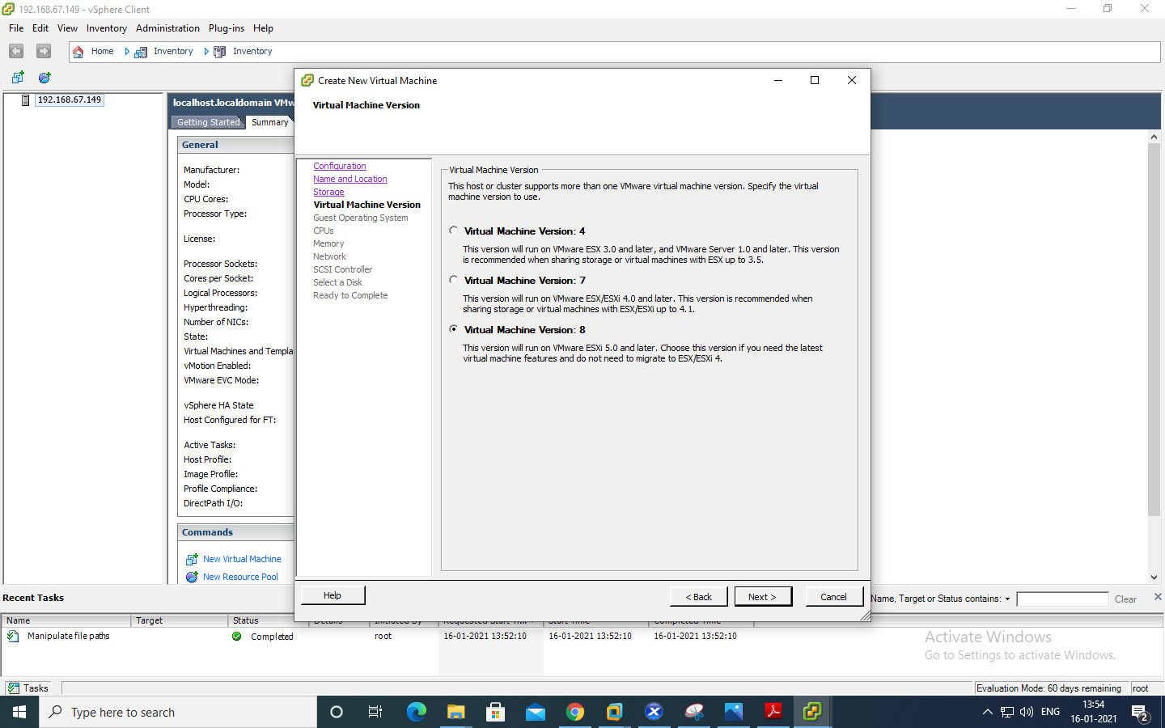

Guest Operating System: Windows

Version: Microsoft windows XP Professional (32-bit)

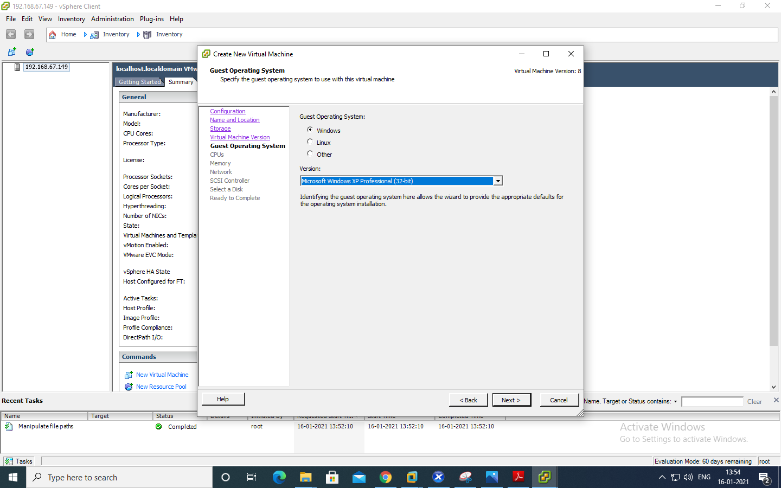

CPUs : Number of virtual sockets : 1

Number of cores per virtual socket: 1

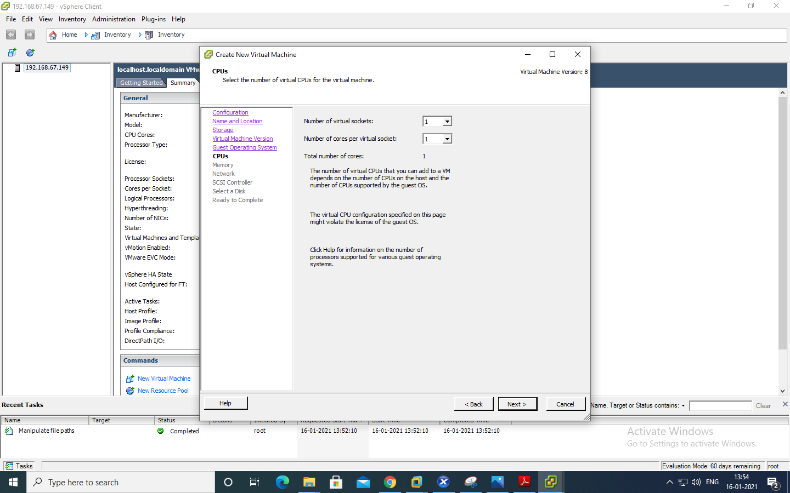

Memory: Memory Size : 1 GB

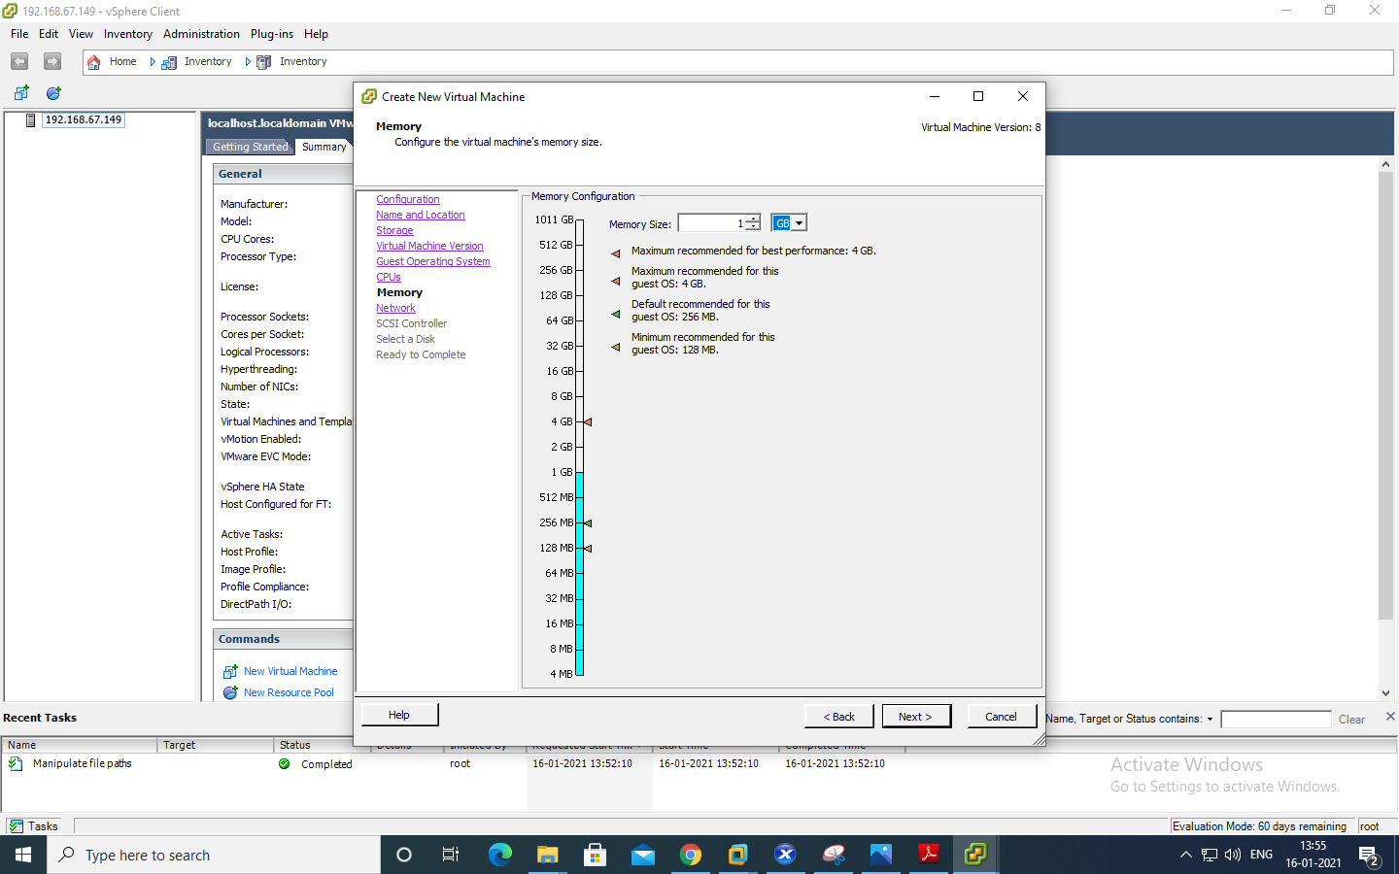

Network: Number of NICs : 1

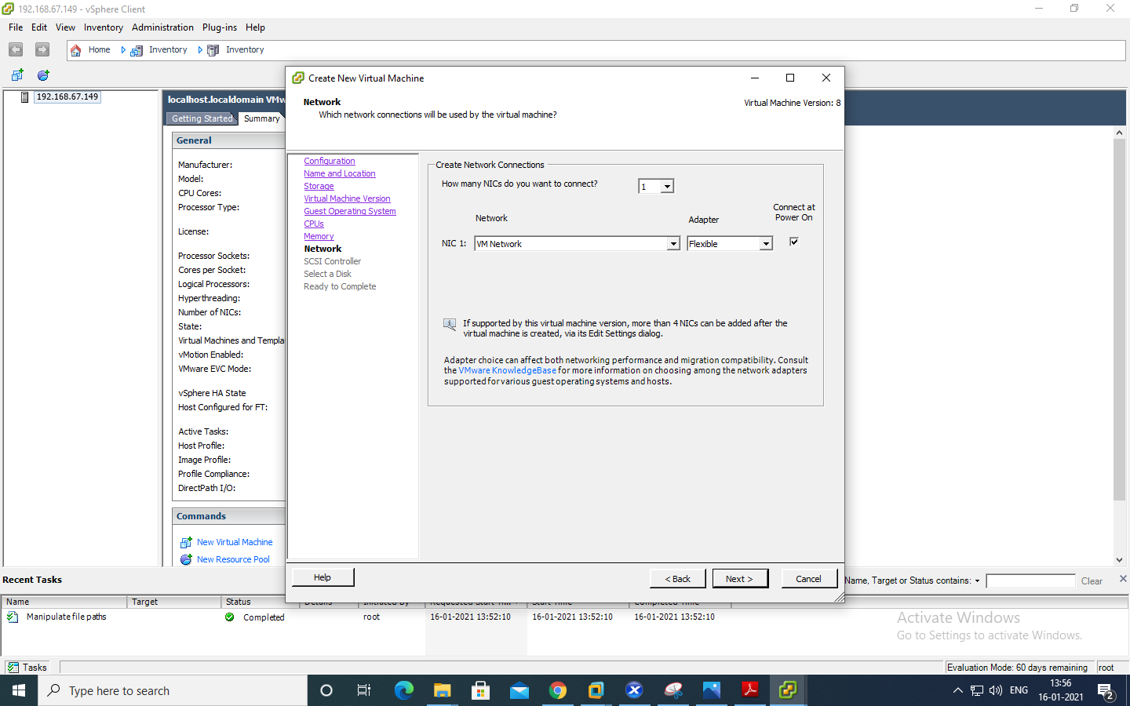

SCSI Controller : VMware Paravirtual

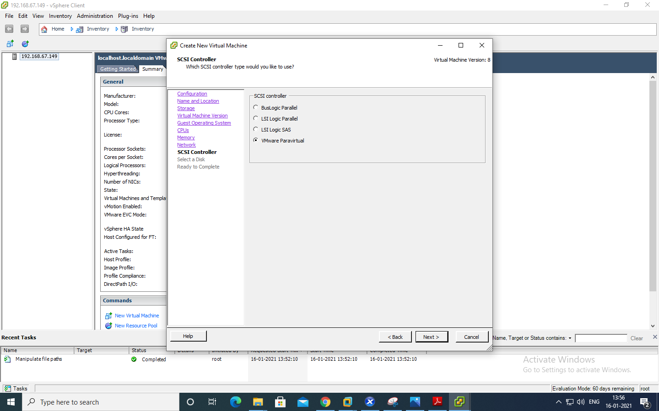

Select a Disk: create new virtual disk.

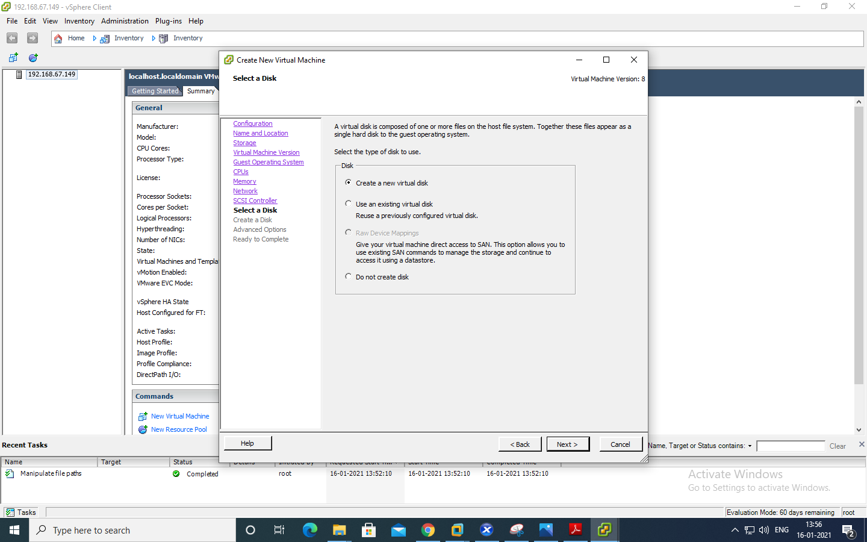

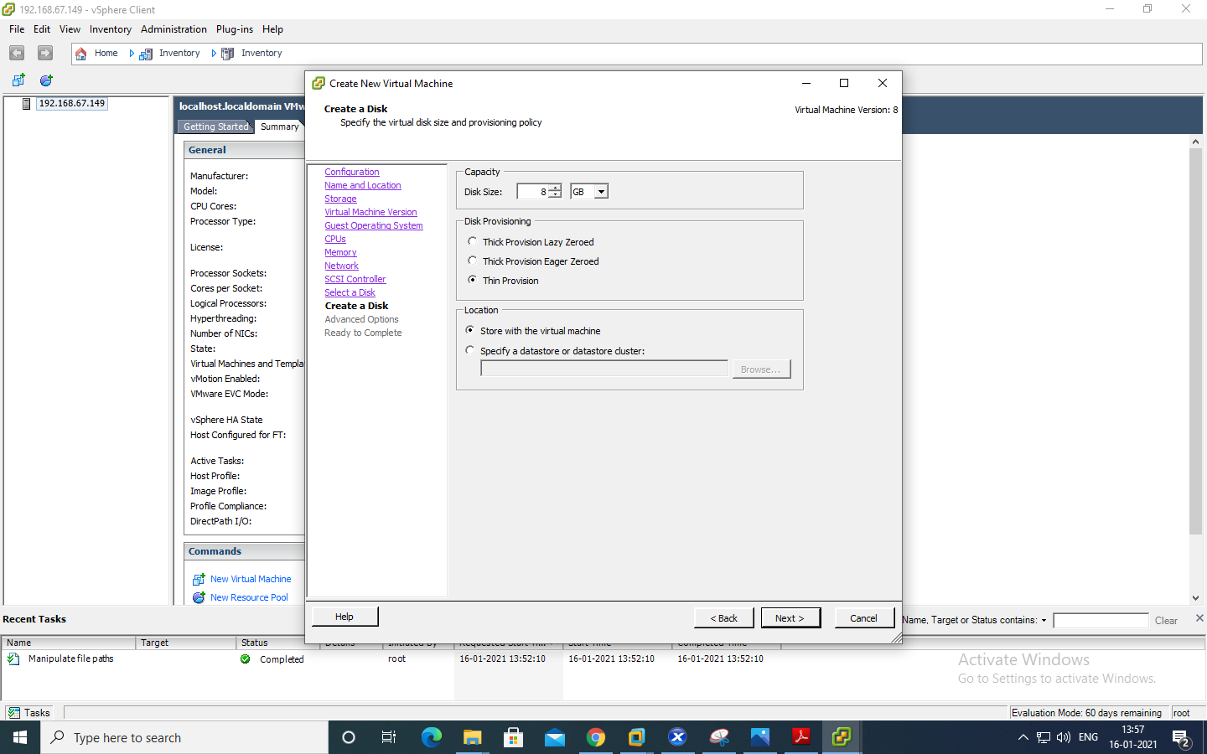

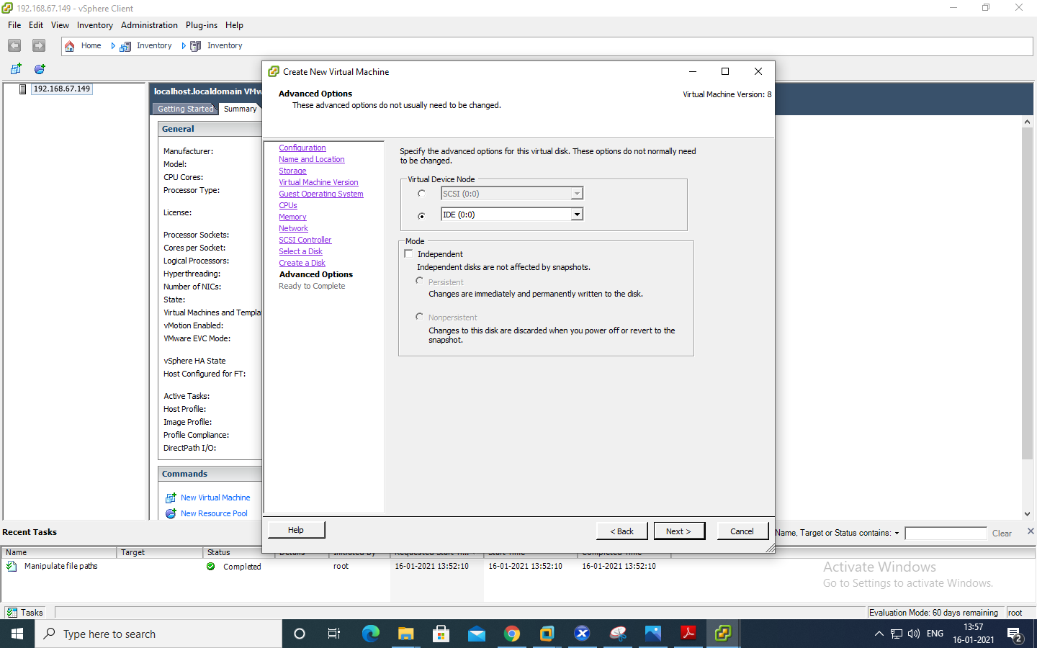

Click edit >> Click on datastore >> Finish

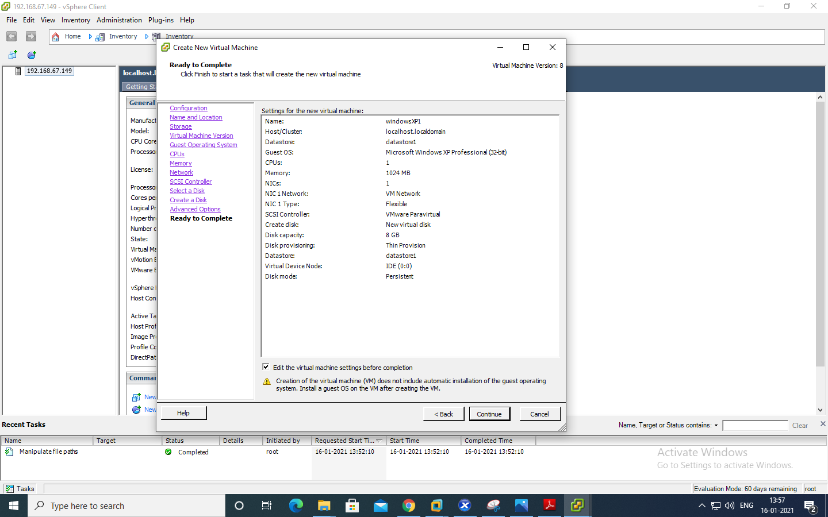

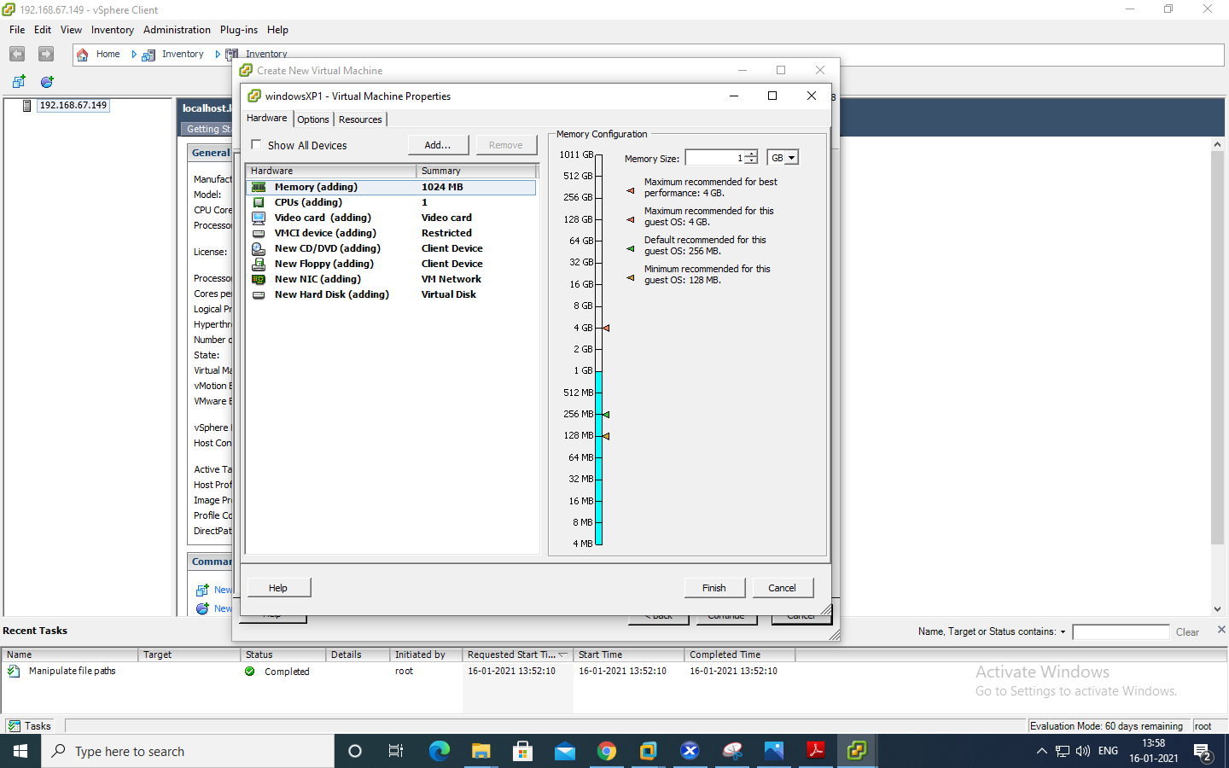

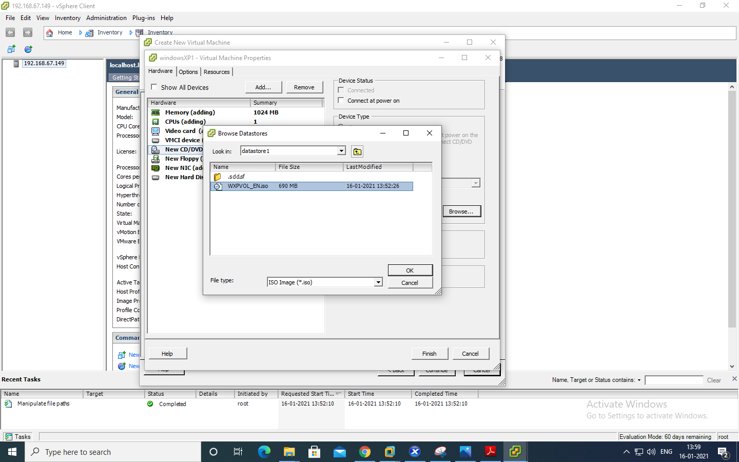

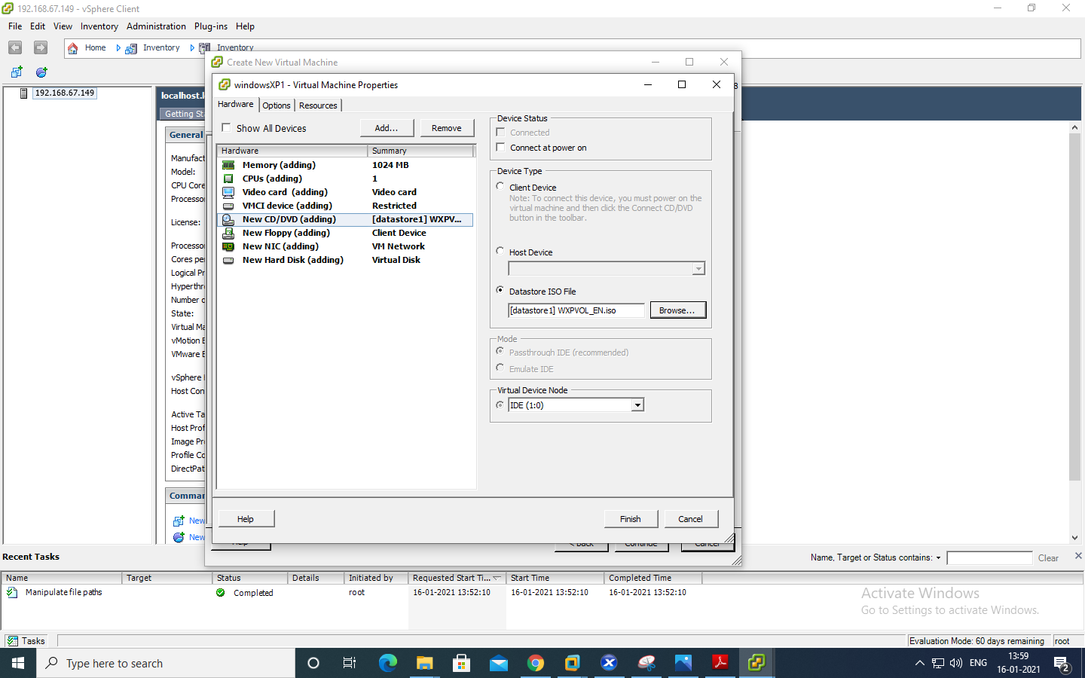

Right Click on Windows XP >> Power >> Power On

